Inverse Kinematic Model

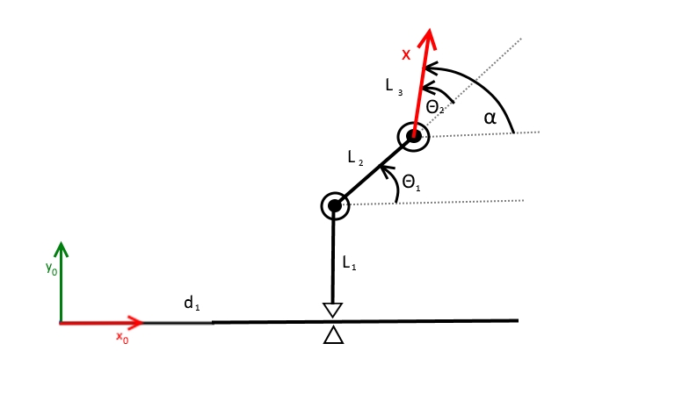

X = ==f(q)

x = d1 + L2cos(Θ1) + L3cos()

y = L1 + L2sin(Θ1) + L3sin()

= Θ1 + Θ2

Θ1 = sin-1()

Θ2 = - Θ1

d1 = x – L2 cos(Θ1) - L3cos()

=